Curriculum Vitae
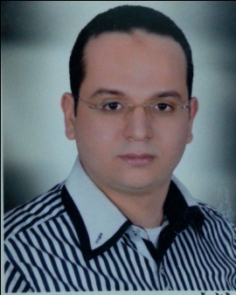
- Personal Data:
• Name: Waleed Gamal El-Din Khalil Ahmed
• Title: M.Sc. Degree Chest disease and tuberculosis
• Current Position: Assistant lecturer of pulmonary medicine, Assuit 2013-till now University Hospitals, Egypt.
• Previous position:
- Demonstrator of pulmonary medicine, AssuitUniversity Hospitals, Egypt 2012-2013
- Resident doctor pulmonary medicine, Assuit2009-2012University Hospitals, Egypt
- Trainer Doctor2008-2009, AssuitUniversity Hospitals, Egypt
• Gender: Male
• Marital status: Married and has one child
• Nationality: Egyptian
• Birth date: October 29th. 1984
• Place of birth: Assuit, Egypt
• Affiliation: Chest Dept., Assiut University Hospitals, Assiut, Egypt
• E-mail: Zander_130@Yahoo.com
Waleed_gamal@aun.edu.eg

Cellular: +201006519722 - Fax: +20882333327 (Hospital Fax)
• Languages: English and Arabic.
• Major specialty: Internal Medicine
• Minor specialty: Pulmonary medicine
• Current Home address: Assiut, Nile Khaton, Cars Insurance Street, Abdelsayed Masjed street, Assiut, Egypt.

B)Qualifications and degrees:
- General certificate of secondary education in 2001.
- MB.BCh., Bachelor degree of medicine and surgery, Assiut faculty ofmedicine, Egypt in 2007 with final grade (Excellent).
- M.Sc. of Chest diseases, Assiut University, Egypt in December 2012 with final grade of (very good).

C) Positions held:
a) Current: Assistant lecturer in pulmonary division, Assuit University.Hospitals, Egypt
b) Past:
- House officer for one year -rotatory- in Assuit University hosp., Egypt.
- Resident doctor pulmonary division, Assuit University hospitals, Egypt.
- Demonstrator pulmonary division, Assuit University hospitals, Egypt.

D) Scientific activities:
- Teaching clinical and theoretical pulmonary medicine for medical students in Assiut University, Assiut, Egypt.
- Supervision of the scientific and clinical performance of junior residents and house officers.
- Attending and participating in organizing national scientific meetings and conferences regularly in Egypt.
- Master thesis entitled Electrolyte Disturbances in Respiratory ICU.
- MD thesis entitled Proportional Assist Ventilation and new indices in weaning of Chronic Obstructive Pulmonary Disease patients.

F) Society membership:
1- Member of the European Respiratory Society (ERS).
2- Member of the Egyptian society of chest physician.

Dr. Waleed Gamal El-Din, M.Sc.
Assistant lecturer of pulmonary medicine
Assiut, Egypt

